**MAT2001 – Statistics for Engineers - ELA (R Code Studio), Winter Semester 2020-2021**

**Lab Assessment - III**

**By: Jonathan Rufus Samuel (20BCT0332) Date: 17.6.2021**

__________________________________________________________________________________

**Write R code to solve the following problems:**

**Q1) In a large consignment of electric bulbs 10 % are defective. A random sample of 20 is taken for inspection. Find the probability that:**

**(i) All are good bulbs,**

**(ii) At most there are 3 defective bulbs,**

**(iii) Exactly there are three defective bulbs.**

A1) Code is as follows:

#Q3.1)

X=20

P=10/100

#None is defective

D1 = dbinom(0,X,P)

print(D1)

#At most 3 bulbs are defective i.e. X<=3

D2 = pbinom(3,X,P)

print(D2)

# P(X=3)

D3 = dbinom(3,X,P)

print(D3)

**Output (via Command Window):**

> #Q2.1)

> X=20

> P=10/100

> #None is defective

> D1 = dbinom(0,X,P)

> print(D1)

[1] 0.1215767

> #At most 3 bulbs are defective i.e. X<=3

> D2 = pbinom(3,X,P)

> print(D2)

[1] 0.8670467

> # P(X=3)

> D3 = dbinom(3,X,P)

> print(D3)

[1] 0.1901199

>

**Implementation on R Studio Code (via Command Window):**

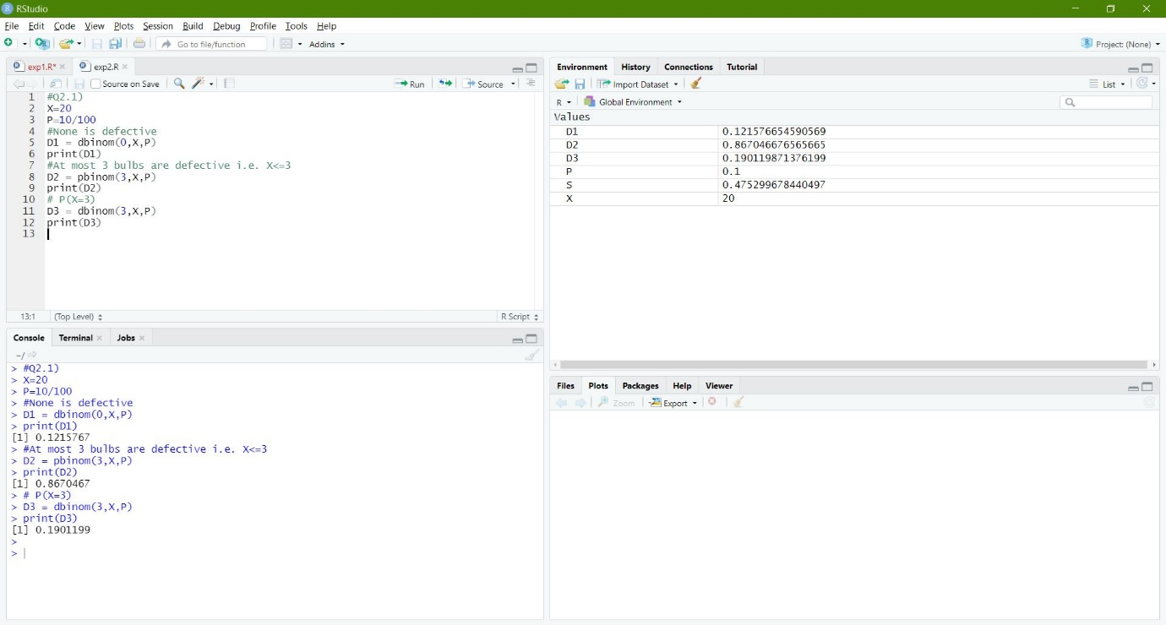

**Q2) Out of 1000 balls 50 are red and the rest white. If 60 balls are picked at random, what is the probability of picking up (i) 3 red balls (ii) not more than 3 red balls in the sample. Assume Poisson distribution for the number of red balls picked up in the sample.**

A1) Code is as follows:

#Q3.2

Pr = 50/1000

Pw = 950/1000

n = 60

m = n * Pr

Lambda = m

# P(X=3)

dpois(3, Lambda)

# Not more than 3 Red balls i.e. P(0)+P(1)+P(2)+P(3)

dpois(0, Lambda)+dpois(1, Lambda)+dpois(2, Lambda)+dpois(3, Lambda)

**Output (via Command Window):**

> #Q3.2

> Pr = 50/1000

> Pw = 950/1000

> n = 60

> m = n * Pr

> Lambda = m

> # P(X=3)

> dpois(3, Lambda)

[1] 0.2240418

> # Not more than 3 Red balls i.e. P(0)+P(1)+P(2)+P(3)

> dpois(0, Lambda)+dpois(1, Lambda)+dpois(2, Lambda)+dpois(3, Lambda)

[1] 0.6472319

**Implementation on R Studio Code (via Command Window):**

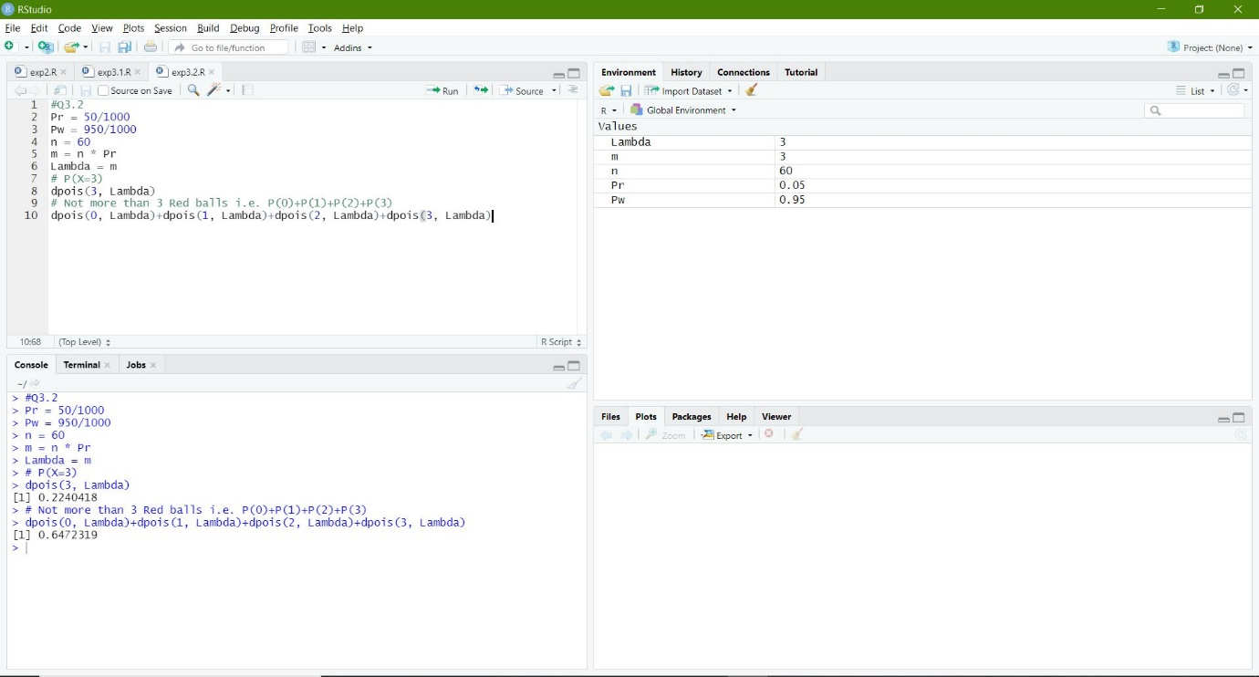

**Q3) In a test on 2000 electric bulbs, it was found that the life of a particular make, was normally distributed with an average life of 2040 hours and S.D. of 60 hours. Estimate the number of bulbs likely to burn for:**

**(i) more than 2150 hours,**

**(ii) less than 1950 hours and**

**(iii) more than 1920 hours but less than 2160 hours.**

A1) Code is as follows:

#Q3.3

mean = 2040

SD = 60

bulbs = 2000

# Number of bulbs > 2150 hours

b1 = pnorm(2150, mean, SD)

b1 = (b1)*bulbs

bulbs-b1

# Number of bulbs < 1950 hours

b2 = pnorm(1950, mean, SD)

b2 = (b2)*bulbs

b2

# Number of bulbs > 1920 and < 2160

b3 = pnorm(2160, mean, SD) - pnorm(1920, mean, SD)

b3 = (b3)*bulbs

b3

**Output (via Command Window):**

> #Q3.3

> mean = 2040

> SD = 60

> bulbs = 2000

> # Number of bulbs > 2150 hours

> b1 = pnorm(2150, mean, SD)

> b1 = (b1)*bulbs

> bulbs-b1

[1] 66.75302

> # Number of bulbs < 1950 hours

> b2 = pnorm(1950, mean, SD)

> b2 = (b2)*bulbs

> b2

[1] 133.6144

> # Number of bulbs > 1920 and < 2160

> b3 = pnorm(2160, mean, SD) - pnorm(1920, mean, SD)

> b3 = (b3)*bulbs

> b3

[1] 1908.999

**Implementation on R Studio Code (via Command Window):**



